Project Design Document

Adam Fitzpatrick – C00273365
Software Development

November 22nd, 2024

Table of Contents
Introduction 2
System Architecture 3
Hardware Technology Stack 3
Waveshare 3.5" IPS Touch Screen 4
Raspberry Pi Zero 2 W 4
Anavi Infrared pHAT 5
Waveshare PN532 NFC HAT 5
Battery (?) 6
Software Technology Stack 7
Raspberry Pi OS 7
Go 7
Fyne 8
Sequence Diagrams 8
Screens 8
References 9

Introduction
The purpose of this design document is to outline the different features of the multi-tool. The document will outline the system architecture and the different technologies that will be utilised, provide diagrams to illustrate the flow of the different interconnected systems and provide illustrations of the various screens that the system will have.

System Architecture

Hardware Technology Stack
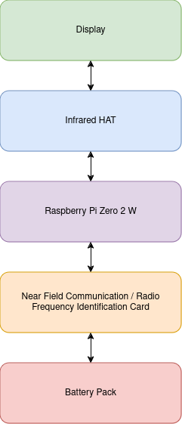

Waveshare 3.5" IPS Touch Screen
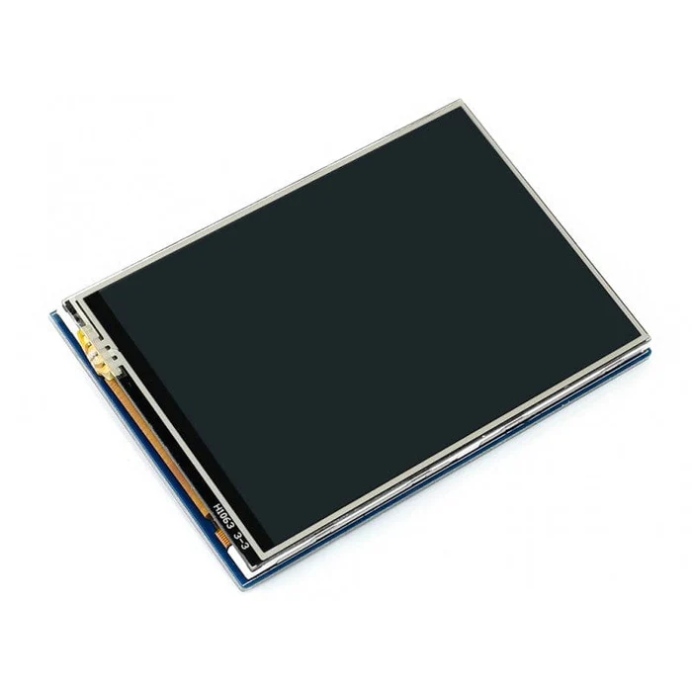
This touch-screen IPS display from Waveshare will be used to show the system menu to the pen-tester. The screen uses a 26 pin header, as opposed to the 40 pin headers that some of the other modules use.

Raspberry Pi Zero 2 W
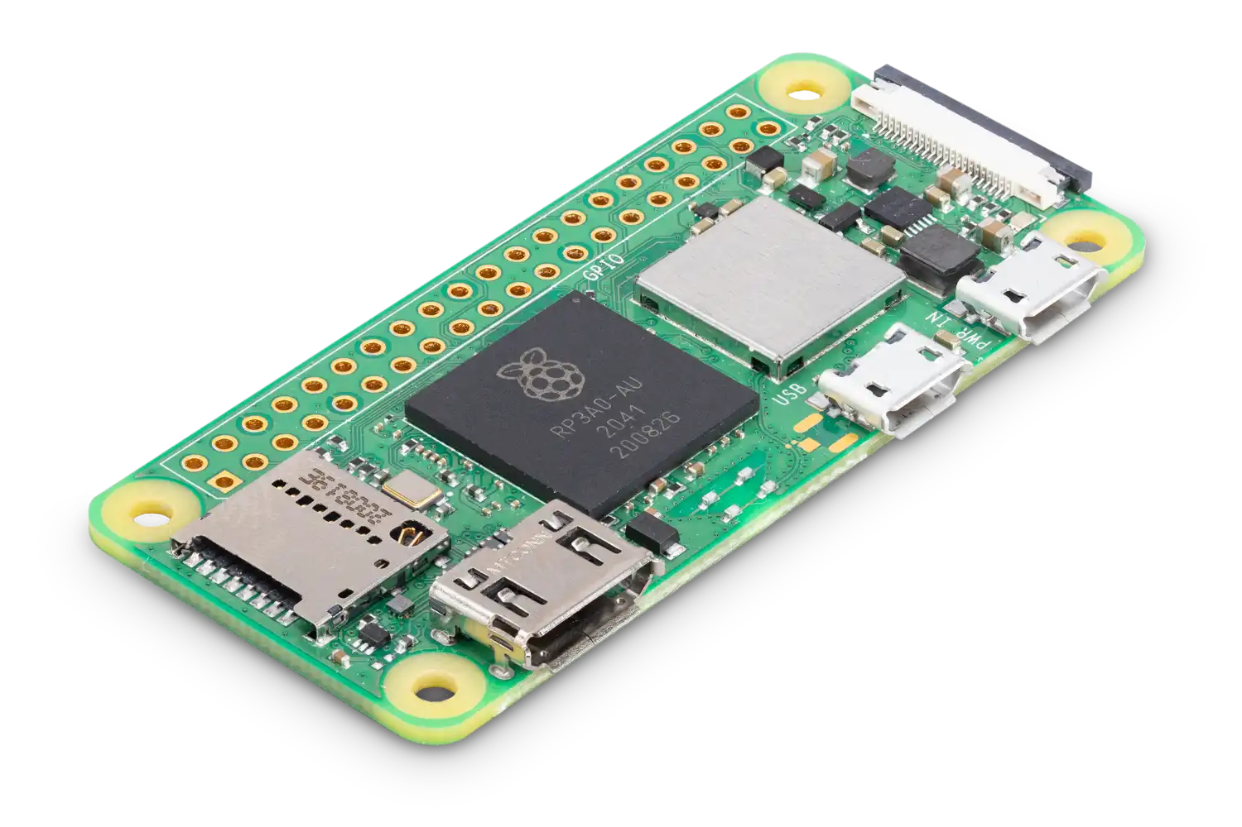
The Raspberry Pi Zero 2 W is a micro-computer and will be the base for this project. The board hosts a quad-core 64 bit ARM central processing unit (CPU) and 512mb of random access memory (RAM). It has built in Wi-Fi and Bluetooth 4.2 which makes it ideal for this project. The board has a 40 pin general-purpose input/output (GPIO) header allowing for inter-connectivity between the different modules in the project. There are also 3 ports on the board, one for HDMI and the other 2 for micro-USB.

Anavi Infrared pHAT
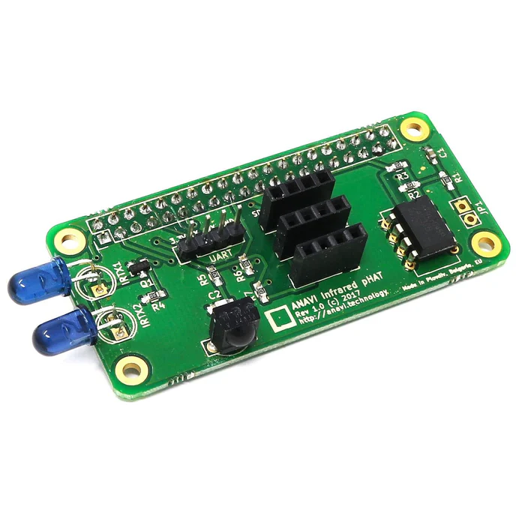
The Anavi Infrared pHAT allows the Raspberry Pi to utilise infrared technologies (IR) though the use of its transmitters a receiver. This will be used to receive and emit our IR signals. The board has a 40 pin GPIO header and also contains sensor modules for temperature, humidity, barometric pressure and light.

Waveshare PN532 NFC HAT
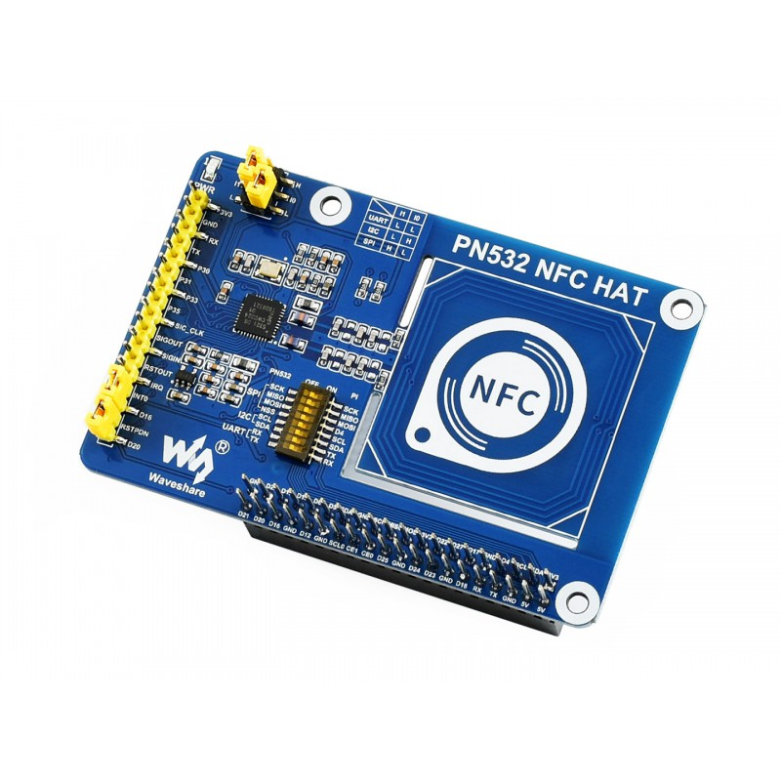
The Waveshare PN532 is a Raspberry Pi HAT designed to allow development boards to utilise Near Field Communications (NFC) and Radio Frequency Identification (RFID) technologies. The HAT has a 40 pin GPIO header and supports various NFC and RFID cards such as MIFARE and NTAG2. This HAT will allow the multi-tool to read and write NFC and RFID signals to and from identification tags and cards.

Battery (?)

Software Technology Stack
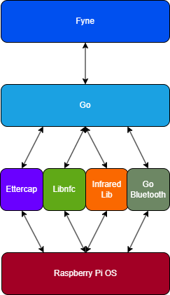

Raspberry Pi OS
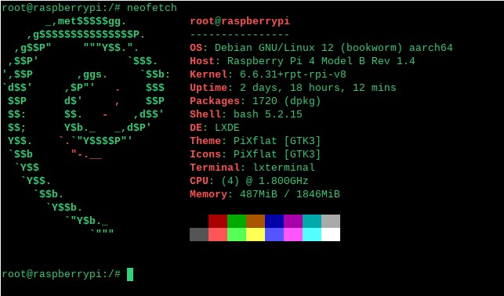
Raspberry Pi OS is the officially supported operating system for the Raspberry Pi. Installing Pi OS is extremely easy, as Raspberry Pi provide an imager to flash the operating system onto an SD card so that it can be used on the board.
The operating system comes in two different installations, those being the Desktop and Lite versions. Both versions are based on Debian, however the two images vary. The Desktop version of the operating system comes as a standard desktop operating system, with some of the main features being it’s graphical user interface (GUI), web browser, media player and even an integrated development environment (IDE).
The Lite version of the operating system is much more bare bones, coming only with a command line interface. Because of this it is faster than it’s Desktop counterpart and allows for much more customizability, however the lack of a GUI and it’s reliability on the command line means that it is less intuitive to use.

Go

Go is a high-level programming language originally designed at Google. It is known for it’s simplicity, efficiency and syntactic similarity to C. This project will utilise Go for behaviour on the back-end such as for inter-compatibility between the different hardware modules.

Fyne
Fyne is an open-source GUI framework for Go. Fyne is designed with simplicity in mind and has a variety of different features that can be used to create applications that run on many different platforms. This framework will be used to make the management menu for the multi-tool system.

Libnfc
Libnfc is a library which gives applications the ability to interact with NFC devices. Specifically this project will use a wrapper by Robert Clausecker to handle the interactions between NFC identification cards and the multi-tool.

Ettercap
Ettercap is an open-source network analysis tool used for network sniffing and man-in-the-middle attacks. It has a variety of filters that can be applied when scanning networks for traffic. For this project this tool will be used for sniffing packets off of Wi-Fi networks.

Infrared Lib
This library is used for interacting with infrared devices on the Raspberry Pi. This library will be used to receive and emit infrared signals from the multi-tool.

Go Bluetooth
Go Bluetooth is a cross-platform package used to interact with Bluetooth Low Energy hardware. For this project this library will be used so that the multi-tool will be able to scan and interact with other Bluetooth enabled devices.

Sequence Diagrams

Wi-Fi Sniffing
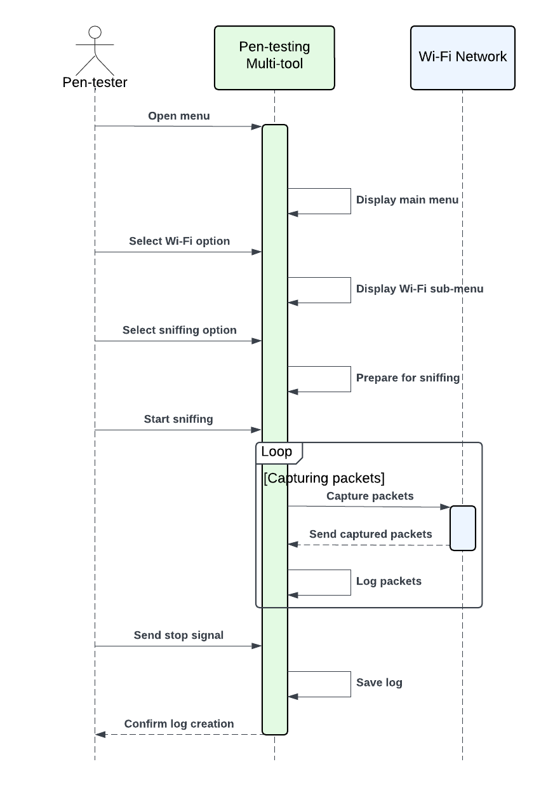
This sequence diagram outlines the process for Wi-Fi packet sniffing, capturing packets, logging packets, and saving the log.

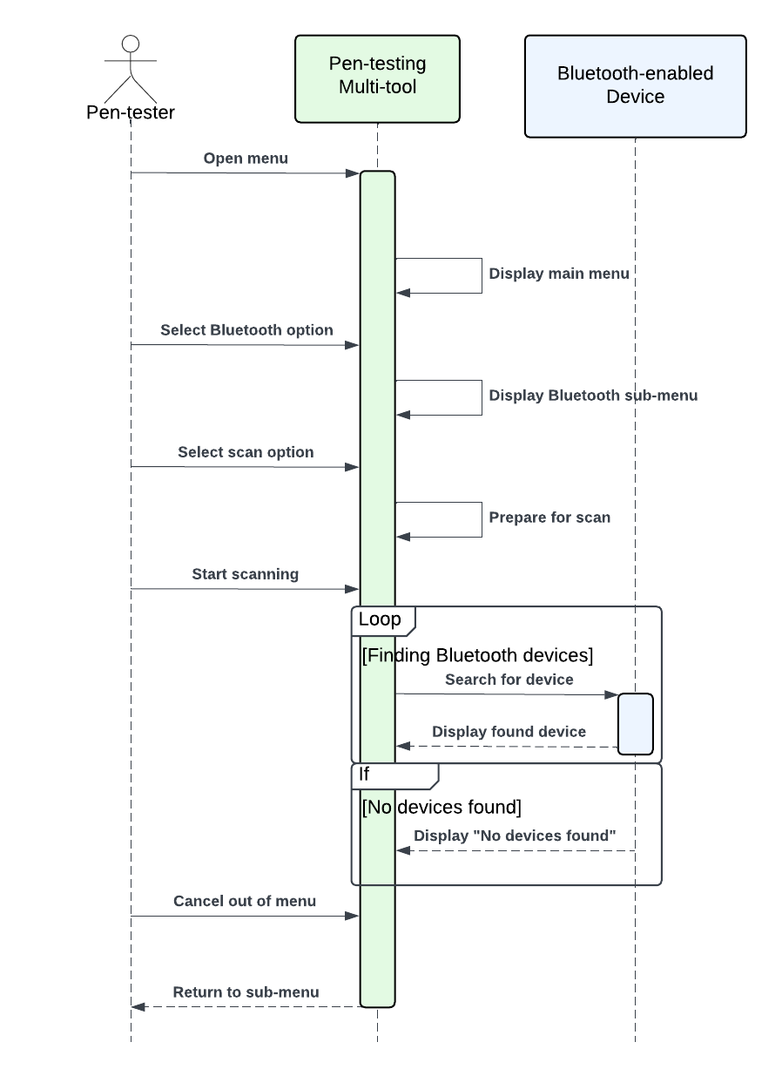
Bluetooth Sniffing
This sequence diagram outlines the sequence of steps for scanning for Bluetooth devices.

NFC Scanning
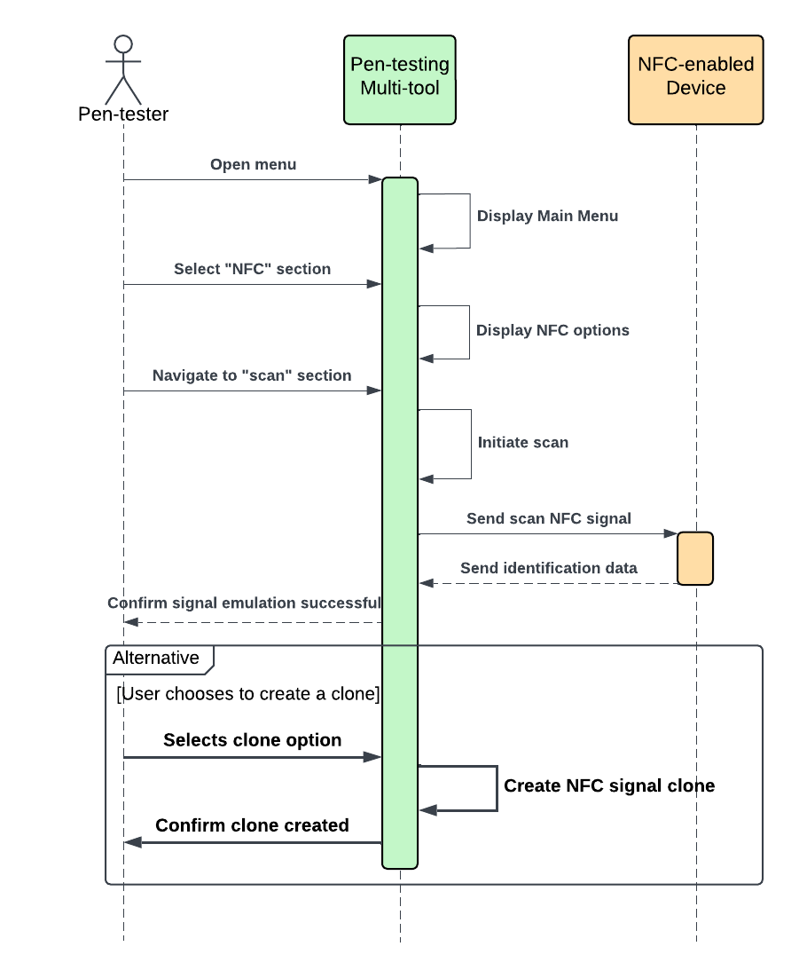
This sequence diagram outlines the process for scanning NFC signals involving displaying the main menu and NFC options, initiating a scan and scanning the signal and being able to create a clone of the NFC signal.

NFC Emulation
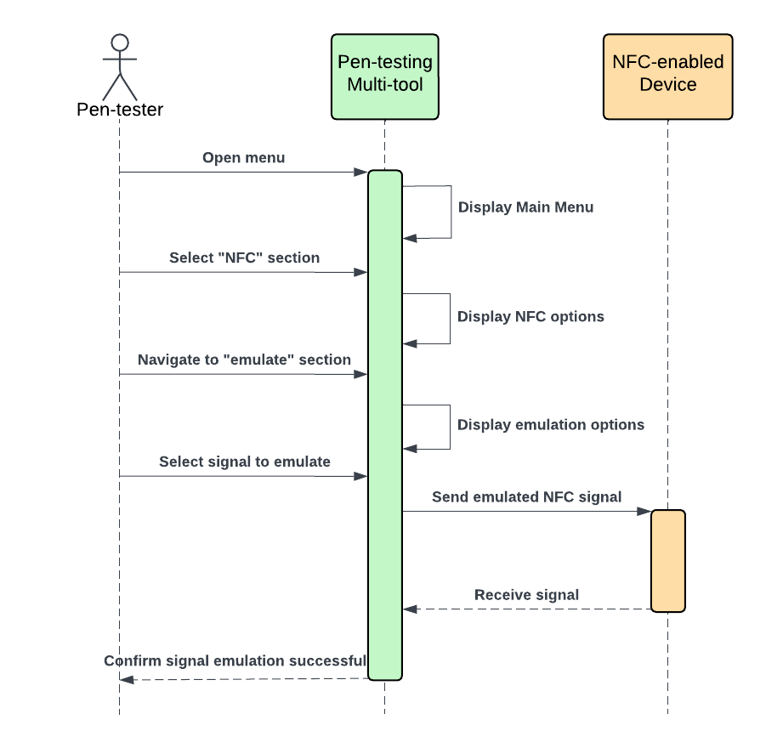
This sequence diagram outlines the process for NFC emulation involving displaying the main menu, NFC options, emulation options and finally emitting the selected NFC signal.

Screens

References

